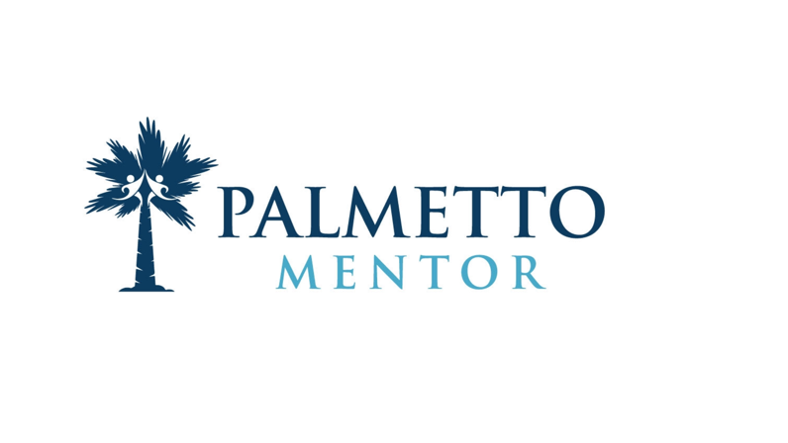
Matching

To increase the odds that a mentoring relationship will endure and be effective, it needs a strong foundation. This begins with a good match. Good matches stem from a high-quality matching process that includes program-specific criteria and takes into account the characteristics of each mentor and mentee. Once the match is made, each participant is given background information about his or her new friend. Then, with the help of the program, the pair officially meets for the first time.

While each program will weight its criteria differently, age and common interests seem to be the strongest factors supporting effective matches, yet there are many other criteria that should be considered when making a match. (The mentor should be at least three years older than the mentee.)
- Similar background (racial, ethnic, cultural, or linguistic)
- Language requirements
- Geographic location
- Availability/schedule
- Shared or compatible interests
- Mentee’s needs and strengths
- Mentor’s skills and strengths
- Life experience
- Shared values
- Temperament
- Personality traits
- Mentor, mentee, and parent/guardian preferences
- Program goals
- Mentoring experience
Matching youth and adults based on shared interests is a strong predictor of successful mentoring relationships—having shared interests allows participants to more easily establish common ground.
This shared understanding might also be established by perceptions of ethnic or cultural similarity, but research doesn’t demonstrate that this always happens, or that it’s as strong of a predictor of quality relationships as shared interests.
However, matching based on shared ethnic or racial identity may be particularly important if the mentee (1) requests it; (2) has limited access to adults who’ve turned similar life experience into positive growth; (3) has a negative self-image tied to his or her life experience; (4) has goals that are best supported by an adult “who’s been there.”

Suggestions for matching that may work in your program:
- Host a group matching event at which prospective mentors and mentees (and potentially parents/guardians) can meet and interact—look for natural chemistry
- Share your match suggestion with parents/guardians to ensure they agree with your recommendation
- Discuss potential opportunities and challenges the mentor may encounter if he or she is matched with a particular mentee
- If ethnic and cultural identity are a feature of or a reality for your program, seek information, resources, and experts to help you adapt your program’s matching process so you can be better informed and more responsive

